Summer Camp 2018
Application

Peknikova 6, Bratislava
info@eel.sk +421 908 548 339

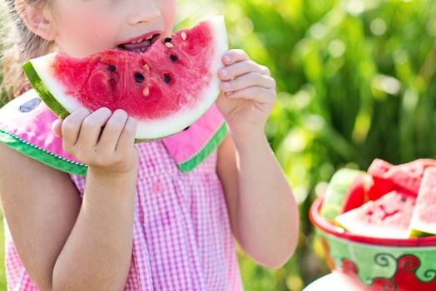
Terms
□ 2-4 & 6 July 2018
□ 9-13 July 2018
□ 13-17 August 2018
□ 20-24 August 2018

Student information
1
Child’s name:
Date of birth:
Health issues or other notes:

2
Child’s name:
Date of birth:
Health issues or other notes:

3
Child’s name:
Date of birth:
Health issues or other notes:

4
Child’s name:
Date of birth:
Health issues or other notes:

Parent information
Name of parent:

Contact phone number:

E-mail address:

Address:

If you wish the invoice to be issued for your company, please write the invoicing details here
Name of company:
Address:
IČO, DIČ, IČ DPH (ID #, tax ID #):

