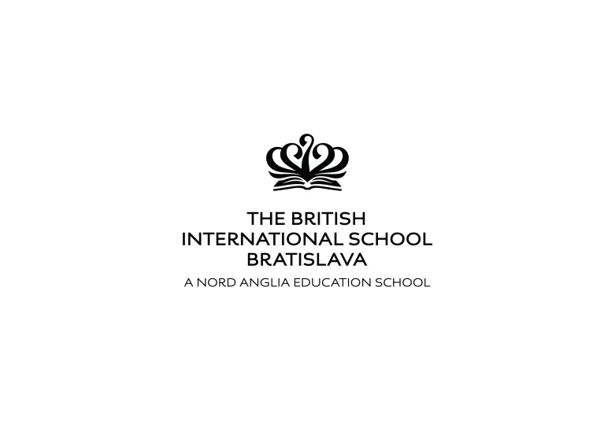

Easter Camp 2018
3-6 April 2018

The Easter Camp is organized as a daily camp at the BIS premises and offers fun activities for children (3-15 years old) with the theme of Easter activities, arts and crafts, and games. We will develop communication skills, support team work and enhance individual strengths. Children with special needs are welcome too.

Activities will include:
- classroom based sessions – children will be in groups organized by age;
- team activities and competitions outside in mixed groups;
- workshops that offer a choice of arts and crafts, drama, music, cooking, and sports.

Time: 9.00 am - 3.00 pm (Children may arrive at 8.30 am and leave by 3.30 pm)
Term | Price | Discounted price*
3-6 April 2018 | 119,- EUR | 109,- EUR

*Discounted prices apply to additional children from one family (119,-eur for the first child, 109,-eur for the second child). .

The price includes a snack and a warm lunch.

Please register for the Easter Camp by e-mail by the 26th March 2018 by sending the application form to:
info@eel.sk

Detailed information about
the BISB & EEL Easter Camp 2018
Dates and times:
3-6 April 2018 (Tuesday to Friday)

Daily from 9:00 to 15:00

Daily Schedule:
09.00 – 09.30 arrivals, greetings, games
09.30 – 10.30 block of activities
10.30 – 10.45 snack break
10.45 – 12.00 block of activities
12.00 – 13.00 lunch break and recess
13.00 – 13.30 team games
13.30 – 14.50 arts and crafts/drama/music/sport workshops and games
from 15.00 clean-up and departure

Programme:
- every day starts with an opening ritual greeting all the children and teachers
- CLASSROOM BASED ACTIVITES are focused on group activities, combining language and problem solving tasks. The lessons are conducted in groups of 13-15 students organized by their age and level of English proficiency. Teachers rotate in the classrooms so that students have the opportunity to get to know different accents and teaching styles.
- TEAM GAMES are organized in mixed groups, different from the core class groups. Teams are selected by children. We support age, gender and individual skill diversity and inclusion. Team games are usually competitions, including physical activities outdoors. Children can practice leadership, learn to cooperate in a team and to appreciate each other’s skills.
- WORKSHOPS allow children to choose the type of activities they like. We always offer SPORT workshops that include learning the rules and practicing e.g. American football, rugby, baseball, cricket, archery, Frisbee, etc.; ARTS and CRAFTS workshops include creating products from paper, boxes, painting, making pasta necklaces, making gifts, etc.; in MUSIC workshops, children learn songs and use everyday objects and music instruments. They learn about composing and performing; DRAMA workshops offer a chance to pretend and become someone else, step into a role and perform a story. It is usually connected with a creative writing workshop. Workshops are selected according to the interests of the students.

Practical information
- parents can bring their children from 8.30 in the morning and take them home by 15.30
- warm lunch is provided (it includes a soup and a meal, full size; children will be able to choose from a few options)
- snacks are provided
- children must bring a water bottle
- we suggest that children wear comfortable clothes and shoes appropriate for sport activities

Examples of activities
- Easter arts and crafts – sewing hand puppets, decorating Easter eggs
- Ester egg hunt
- Story telling – listening to stories and re-telling them (youngest learners), creating stories based on pictures, words, hints
- Comic strips, puppets, and film making
- Songs and their lyrics – learning new phrases from songs and discussing their themes
- Healthy foods for a spring revival
- Young animals – puppies, kittens, etc.
- Games – learning through games – new vocabulary and problem solving
- Field trip – to be determined based on the number of children signed-up at their age

Main goals:
- students will enjoy the holiday in a group of peers
- students will develop their social and communication skills
- students will learn English in a fun way by participating in group activities
- students will improve their listening skills by talking to native speakers
- students will build a positive attitude towards English language
- students will feel relaxed in the friendly learning environment
- students will see the teachers as friends and role models

Teachers:
All our teachers are native English speakers who have experience with teaching children, teenagers, and adults. We will provide a number of teachers necessary to make groups of 13-15 children according to how many children sign up. We will also have assistant camp counsellors to provide supervision over the breaks, assistance to teachers in addressing individual needs of students and other necessary help. The adult/teacher ratio will be at least 1 adult on 10 children.

Camp directors:
Dr Ivana Lessner Listiakova has been working with children and families since 2007. She provides learning support for children, using methods of creative arts therapies and occupational therapy. She also works at University of Northampton.
Eric E. Lessner has been teaching English as a second language in Europe since 2001. He has worked in summer camps for over 20 years and organized summer camps in California, Italy, Austria and Slovakia. During the school year Expert European Linguistics organizes English Native Speaker Project Weeks and educational trips, language lessons for children and adults.

Health and safety: We require parents to inform us about any health issues that their children might have.

Students:
The camp will be offered primarily for students of BISB. After that, students from other schools in Bratislava will be invited. Ages: 3-15.
Groups will be made according to the age of children and their level of English.
E.g.: 5-6 year olds, 7-9 year olds, 10-12 year olds, 13-14 year olds. Individual needs will be considered.

Sign-up information and deadlines:
Applications will be sent by e-mail to info@eel.sk .
Deadline for the applications is 26th March 2018. After this date parents are asked to contact the organizer to inquire about available places in the programme.
Payments for the camp will be accepted by bank transfer on the EEL account the latest by the 30th March 2018. Cash payments or late payments need to be arranged with the organizer.
The payment is not refundable in case of change of holiday plans, neither when the child misses a part of the programme from any reasons. In case of serious reasons, such as illness proved by a doctor’s note, 50% of the price of the missed part of the programme will be refunded.
Later applications will be accepted only after individual consultations with the organizer and will be considered according to the number of capacities. These include also consultations with The Admissions Officer Ms. Milina Bireš regarding newly accepted students. These applications will be primarily accepted also after the registration deadline.

Bank information:
Bank account holder: Expert European Linguistics s. r. o.
Bank account number: 2946187856/0200 VÚB, a.s.
IBAN: SK85 0200 0000 0029 4618 7856 SWIFT: SUBASKBX

Contact information
For more information visit our website www.eel.sk.
Email: info@eel.sk
Phone: + 421 908 548 339
Ivana Lessner Listiakova, PhD.

We are looking forward to seeing you at our camp!

