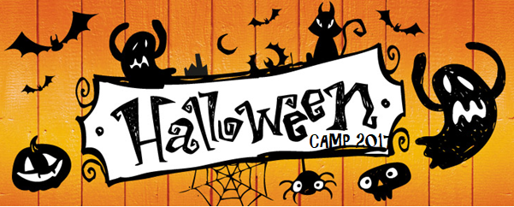
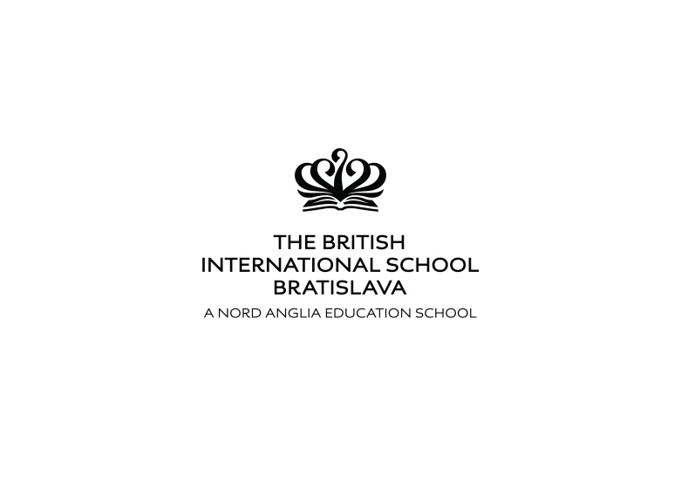

Halloween Camp 2017

will take place at BISB Peknikova site
during the autumn break
30th – 31st October and 2nd – 3rd November 2017

The Halloween Camp is organized as a daily camp at the BIS premises and offers fun activities for children (3-15 years old) with the theme of Halloween traditions, arts and craft, and games. We will develop communication skills, support team work and enhance individual strengths. Children with special needs are welcome too.
Activities will include:
- classroom based sessions – children will be in groups organized by age;
- team activities and competitions outside in mixed groups;
- workshops that offer a choice of arts and crafts, drama, music, cooking, and sports.

Time: 9.00 am - 3.00 pm (Children may arrive at 8.30 am and leave by 3.30 pm)
Term | Price | Discounted price*
30-31 October & 2-3 November | 119,- EUR | 109,- EUR

*Discounted prices apply to additional children from one family.

The price includes a snack and a warm lunch.

Please register for the Halloween Camp by e-mail by the 15th October 2017.
info@eel.sk

Detailed information about
the BISB & EEL Halloween Autumn Camp 2017
Dates and times:
30-31 October & 2-3 November 2017

Daily from 9:00 to 15:00

Daily Schedule:
09.00 – 09.30 arrivals, greetings, games
09.30 – 10.30 block of activities
10.30 – 10.45 snack break
10.45 – 12.00 block of activities
12.00 – 13.00 lunch break and recess
13.00 – 13.30 team games
13.30 – 14.50 arts and crafts/drama/music/sport workshops and games
from 15.00 clean-up and departure

Programme:
- every day starts with an opening ritual greeting all the children and teachers
- CLASSROOM BASED ACTIVITES are focused on group activities, combining language and problem solving tasks. The lessons are conducted in groups of 13-15 students organized by their age and level of English proficiency. Teachers rotate in the classrooms so that students have the opportunity to get to know different accents and teaching styles.
- TEAM GAMES are organized in mixed groups, different from the core class groups. Teams are selected by children. We support age, gender and individual skill diversity and inclusion. Team games are usually competitions, including physical activities outdoors. Children can practice leadership, learn to cooperate in a team and to appreciate each other’s skills.
- WORKSHOPS allow children to choose the type of activities they like. We always offer SPORT workshops that include learning the rules and practicing e.g. American football, rugby, baseball, cricket, archery, Frisbee, etc.; ARTS and CRAFTS workshops include creating products from paper, boxes, painting, making pasta necklaces, making gifts, etc.; in MUSIC workshops, children learn songs and use everyday objects and music instruments. They learn about composing and performing; DRAMA workshops offer a chance to pretend and become someone else, step into a role and perform a story. It is usually connected with a creative writing workshop. Workshops are selected according to the interests of the students.

Practical information
- parents can bring their children from 8.30 in the morning and take them home by 15.30
- warm lunch is provided (it includes a soup and a meal, full size; children will be able to choose from a few options)
- snacks are provided
- children must bring a water bottle
- we suggest that children wear comfortable clothes and shoes appropriate for sport activities

Examples of activities
- Halloween decorations – making spiders, bats, ghosts, etc.
- Halloween costumes – making masks and costumes
- Story telling – listening to stories and re-telling them (youngest learners), creating stories based on pictures, words, hints
- Halloween comic strips
- Halloween film making
- Songs and their lyrics – learning new phrases from songs and discussing their themes
- Making Halloween fun snacks
- Games – learning through games – new vocabulary and problem solving

Main goals:
- students will enjoy the holiday in a group of peers
- students will develop their social and communication skills
- students will improve their language skills, especially speaking
- students will become more confident language users
- students will learn English in a fun way by participating in group activities
- students will expand their vocabulary
- students will improve their listening skills by talking to native speakers
- students will build a positive attitude towards English language
- students will feel relaxed in the friendly learning environment
- students will see the teachers as friends and role models
Teachers:
All our teachers are native English speakers who have experience with teaching children, teenagers, and adults. We will provide a number of teachers necessary to make groups of 13-15 children according to how many children sign up. We will also have assistant camp counsellors to provide supervision over the breaks, assistance to teachers in addressing individual needs of students and other necessary help. The adult/teacher ratio will be at least 1 adult on 10 children.
Camp directors:
Eric E. Lessner has been teaching English as a second language in Europe since 2001. He has worked in summer camps for over 20 years and organized summer camps in California, Italy, Austria and Slovakia. During the school year Expert European Linguistics organizes English Native Speaker Project Weeks and educational trips, language lessons for children and adults.
Mgr. Ivana Lessner Lištiaková, PhD. is a therapeutic educator. She has worked with children with learning difficulties, physical and mental disabilities coming from different cultural and language backgrounds. She has been providing OT support for students of BISB since 2008. She has directed multicultural English programmes for children and youth. She also works at Comenius University in Bratislava.
Health and safety: We require parents to inform us about any health issues that their children might have.
Students:
The camp will be offered primarily for students of BISB. After that, students from other schools in Bratislava will be invited. Ages: 3-15.
Groups will be made according to the age of children and their level of English.
E.g.: 5-6 year olds, 7-9 year olds, 10-12 year olds, 13-14 year olds. Individual needs will be considered.
Sign-up information and deadlines:
Applications will be sent by e-mail to info@eel.sk .
Deadline for the applications is 15th October 2017. After this date parents are asked to contact the organizer to inquire about available places in the programme.
Payments for the camp will be accepted by bank transfer on the EEL account the latest by the 27th October 2017. Cash payments or late payments need to be arranged with the organizer.
The payment is not refundable in case of change of holiday plans, neither when the child misses a part of the programme from any reasons. In case of serious reasons, such as illness proved by a doctor’s note, 50% of the price of the missed part of the programme will be refunded.
Later applications will be accepted only after individual consultations with the organizer and will be considered according to the number of capacities. These include also consultations with The Admissions Officer Ms. Milina Bireš regarding newly accepted students. These applications will be primarily accepted also after 15th October 2017.

Bank information:
Bank account holder: Expert European Linguistics s. r. o.
Bank account number: 2946187856/0200 VÚB, a.s.
IBAN: SK85 0200 0000 0029 4618 7856 SWIFT: SUBASKBX

Contact information
For more information visit our website www.eel.sk.
Email: info@eel.sk
Phone: + 421 908 548 339
Ivana Lessner Listiakova

We are looking forward to seeing you at our camp!

